Top trees | Tuff Tray | Rope play (adult led)
To know parts of 10  Be able to order numbers to 10  OIrdering the large log numbers.  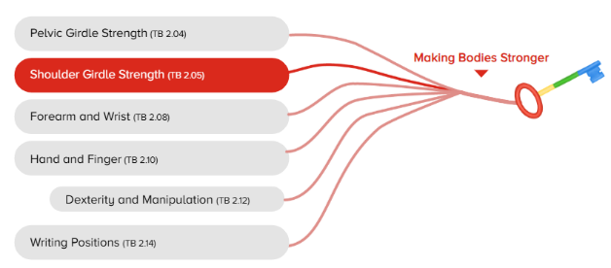  Folling ten frames with natural objects: adults to model parts of ten. | Be able to paint using colours for purpose  Children to paint a garden scene using the water colours. Adults to model what they might see and talk about the colours they might use.  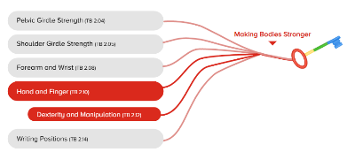 | BE able to pull/push with strength in shoulders and arms  Be able to control impulses (wait for turn)  Pulling buckets of water using a pulley system  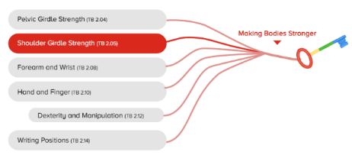
Reading/writing | Paint (Maths) | Movement
Word hunt:  ch/ck/Unit 1 blends  Be able to draw what they observe  Clip boards and pens available for them to draw the birds/bugs that they find | To know the words ‘slither’ and ‘trail’  Children to create snail trails with glitter and glue (adult to model the words as they make them). | 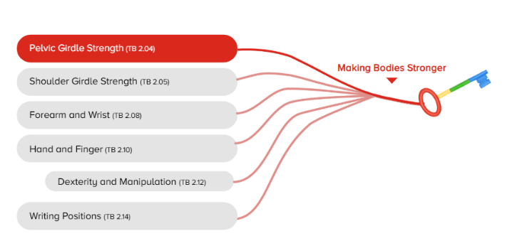  Space hopper practise!
Natural World | Water | Mud kitchen
To know the names of bugs in our environment and where there habitats are. Model HQT and using taught vocabulary.  Bug hunts using the check list.  Vocab: legs, scurry, slow, shell, hide, wing, foot, names | Be able to transport without a spill  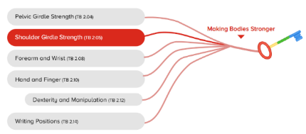  Children to use ladles to transport water from place to place without spill.  To know the words fast and slow  Water drain play: exploring the speed of water | To know and secribe what happens when we mix sand and water using funnels  Adult to model language of change to children as they consolidate their understanding of mixing  Vocab: mix, stir, see through, now see through, powder, stiff
WB 22.6.26

